SECTION 1: Identification of the substance/mixture and of the company/undertaking

1.1. Product identifier
Product form | : | Mixture
Product name | : | FRANKINCENSE & MYRRH #EU25961F 25% in DPG
Product code | : | EU25961F_25%
Type of product | : | Perfumes, fragrances
Product group | : | Trade product

1.2. Relevant identified uses of the substance or mixture and uses advised against

1.2.1. Relevant identified uses
Main use category | : | Professional use,Industrial use
Industrial/Professional use spec | : | Industrial  For professional use only
Use of the substance/mixture | : | Perfumes, fragrances
Function or use category | : | Odour agents

1.2.2. Uses advised against
No additional information available

1.3. Details of the supplier of the safety data sheet
FRENCH COLOR & FRAGRANCE International GmbH
Mittlerer Weg 35
DE– 79424 Auggen
Germany
T 49-7631-931-8900
SDS@frenchcolor.com - www.frenchcolor.com

1.4. Emergency telephone number
Emergency number | : | 1-800-255-3924; +01-813-248-0585; China:+400-120-0751; Mexico:+01-800-099-0731; Brazil: +0-800-591-6042; India: +000-800-100-4086

SECTION 2: Hazards identification

2.1. Classification of the substance or mixture

Classification according to Regulation (EC) No. 1272/2008 [CLP]
Skin sensitisation, Category 1 | H317
Hazardous to the aquatic environment – Chronic Hazard, Category 2 | H411
Full text of H- and EUH-statements: see section 16

Adverse physicochemical, human health and environmental effects
Toxic to aquatic life with long lasting effects. May cause an allergic skin reaction.

2.2. Label elements

Labelling according to Regulation (EC) No. 1272/2008 [CLP]
Hazard pictograms (CLP) | : | 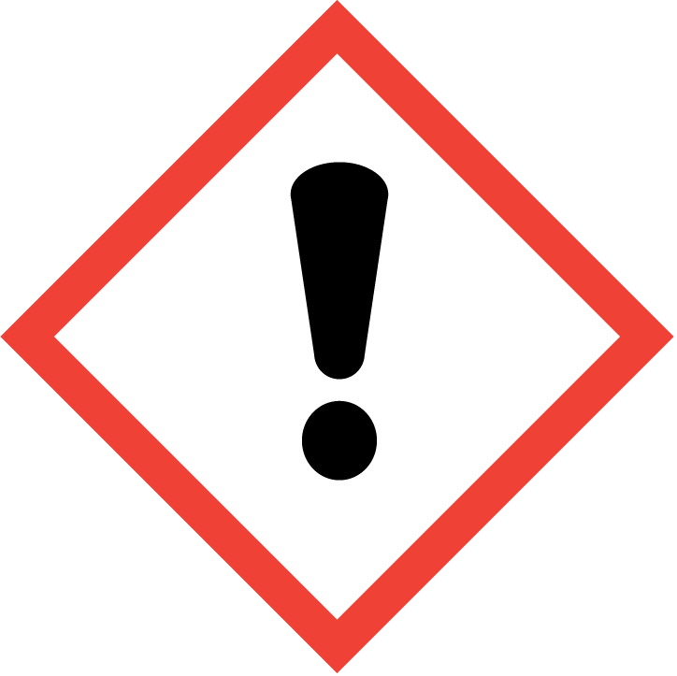 | 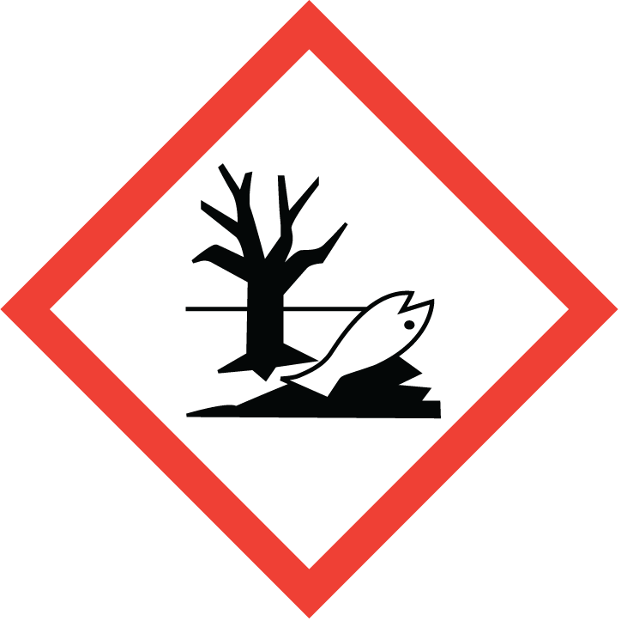
 |  | GHS07 | GHS09
Signal word (CLP) | : | Warning
Contains | : | Iso E Super; Clove Leaf Oil ; Eugenol; Linalyl acetate; Linalool; Grapefruit oil; Cinnamic aldehyde; beta-Caryophyllene; Methyl cinnamate; Eucalyptus oil; Helional; Patchouli oil
Hazard statements (CLP) | : | H317 - May cause an allergic skin reaction.  H411 - Toxic to aquatic life with long lasting effects.
Precautionary statements (CLP) | : | P261 - Avoid breathing dust/fume/gas/mist/vapours/spray.  P272 - Contaminated work clothing should not be allowed out of the workplace.  P273 - Avoid release to the environment.  P280 - Wear protective gloves/protective clothing/eye protection/face protection/hearing protection.  P302+P352 - IF ON SKIN: Wash with plenty of water.  P321 - Specific treatment (see supplemental first aid instruction on this label).
Extra phrases | : | For professional users only.

2.3. Other hazards
Contains no PBT and/or vPvB substances ≥ 0.1% assessed in accordance with REACH Annex XIII

The mixture does not contain substance(s) included in the list established in accordance with Article 59(1) of REACH for having endocrine disrupting properties, or is not identified as having endocrine disrupting properties in accordance with the criteria set out in Commission Delegated Regulation (EU) 2017/2100 or Commission Regulation (EU) 2018/605 at a concentration equal to or greater than 0,1 %

SECTION 3: Composition/information on ingredients

3.1. Substances
Not applicable

3.2. Mixtures
Name | Product identifier | % | Classification according to Regulation (EC) No. 1272/2008 [CLP]
Iso E Super | CAS-No.: 54464-57-2  EC-No.: 259-174-3  REACH-no: 01-2119489989-04 | 1.425 – 2.83 | Skin Irrit. 2, H315  Skin Sens. 1, H317  Aquatic Chronic 1, H410
1-[(2-tert-butyl)cyclohexyloxy]-2-butanol | CAS-No.: 139504-68-0  EC-No.: 412-300-2  EC Index-No.: 603-154-00-2  REACH-no: 01-0000015959-52 | 1.025 – 2.025 | Aquatic Chronic 2, H411
Dihydromyrcenol | CAS-No.: 18479-58-8  EC-No.: 242-362-4  REACH-no: 01-2119457274-37 | 0.75 – 1.5 | Skin Irrit. 2, H315  Eye Irrit. 2, H319
Clove Leaf Oil | CAS-No.: 8000-34-8  EC-No.: 616-772-2 | 0.475 – 0.95 | Eye Irrit. 2, H319  Skin Sens. 1, H317  Asp. Tox. 1, H304
1,3,4,6,7,8-hexahydro-4,6,6,7,8,8-hexamethylindeno[5,6-c]pyran; galaxolide; (HHCB) | CAS-No.: 1222-05-5  EC-No.: 214-946-9  EC Index-No.: 603-212-00-7  REACH-no: 01-2119488227-29 | 0.45 – 0.8875 | Aquatic Acute 1, H400  Aquatic Chronic 1, H410
Eugenol | CAS-No.: 97-53-0  EC-No.: 202-589-1  REACH-no: 01-2119971802-33 | 0.45 – 0.8875 | Acute Tox. 4 (Oral), H302  Eye Irrit. 2, H319  Skin Sens. 1B, H317
Linalyl acetate | CAS-No.: 115-95-7  EC-No.: 204-116-4  REACH-no: 01-2119454789-19 | 0.375 – 0.725 | Skin Irrit. 2, H315  Eye Irrit. 2, H319  Skin Sens. 1, H317
Linalool | CAS-No.: 78-70-6  EC-No.: 201-134-4  EC Index-No.: 603-235-00-2  REACH-no: 01-2119474016-42 | 0.325 – 0.625375 | Skin Irrit. 2, H315  Eye Irrit. 2, H319  Skin Sens. 1B, H317
Grapefruit oil | CAS-No.: 8016-20-4  EC-No.: 600-007-4 | 0.25 – 0.5125 | Flam. Liq. 3, H226  Skin Irrit. 2, H315  Skin Sens. 1, H317  Asp. Tox. 1, H304  Aquatic Chronic 2, H411
Cinnamic aldehyde | CAS-No.: 104-55-2  EC-No.: 203-213-9  REACH-no: 01-2119935242-45 | 0.225 – 0.4375 | Acute Tox. 4 (Dermal), H312  Skin Irrit. 2, H315  Eye Irrit. 2, H319  Skin Sens. 1A, H317  Aquatic Chronic 3, H412
beta-Caryophyllene | CAS-No.: 87-44-5  EC-No.: 201-746-1  REACH-no: 01-2120745237-53 | 0.225 – 0.4375 | Skin Sens. 1B, H317  Asp. Tox. 1, H304
Cedarwood oil, Texas | CAS-No.: 68990-83-0  EC-No.: 294-461-7 | 0.15 – 0.2875 | Asp. Tox. 1, H304  Aquatic Acute 1, H400  Aquatic Chronic 1, H410
Methyl cinnamate | CAS-No.: 103-26-4  EC-No.: 203-093-8  REACH-no: 01-2119979458-16 | 0.1 – 0.175 | Skin Sens. 1B, H317
Eucalyptus oil | CAS-No.: 8000-48-4  EC-No.: 283-406-2  REACH-no: 01-2119978250-37 | 0.075 – 0.125 | Flam. Liq. 3, H226  Skin Irrit. 2, H315  Skin Sens. 1, H317  Asp. Tox. 1, H304  Aquatic Chronic 2, H411
Helional | CAS-No.: 1205-17-0  EC-No.: 214-881-6  REACH-no: 01-2120740119-58 | 0.05 – 0.1 | Skin Sens. 1B, H317  Repr. 2, H361  Aquatic Chronic 2, H411
Patchouli oil | CAS-No.: 8014-09-3  EC Index-No.: 616-944-7 | 0.05 – 0.1 | Skin Sens. 1B, H317  Asp. Tox. 1, H304  Aquatic Chronic 2, H411
citral  substance with national workplace exposure limit(s) (BE, ES, IE, PL, PT) | CAS-No.: 5392-40-5  EC-No.: 226-394-6  EC Index-No.: 605-019-00-3  REACH-no: 01-2119462829-23 | 0.025 – 0.05 | Skin Irrit. 2, H315  Eye Irrit. 2, H319  Skin Sens. 1, H317
.alpha.-Pinene  substance with national workplace exposure limit(s) (BE, EE, ES, LT, PT, SE, NO) | CAS-No.: 80-56-8  EC-No.: 201-291-9 | 0.0025 – 0.009375 | Flam. Liq. 3, H226
.beta.-Pinene  substance with national workplace exposure limit(s) (BE, EE, ES, LT, PT, SE, NO) | CAS-No.: 127-91-3  EC-No.: 204-872-5 | 0.00125 – 0.0375 | Flam. Liq. 3, H226
(R)-p-mentha-1,8-diene; d-limonene  substance with national workplace exposure limit(s) (DE, ES, FI, SI, NO, CH) | CAS-No.: 5989-27-5  EC-No.: 205-341-0  EC Index-No.: 601-096-00-2  REACH-no: 01-2119493353-35 | 0.000625 – 0.015 | Flam. Liq. 3, H226  Skin Irrit. 2, H315  Skin Sens. 1B, H317  Asp. Tox. 1, H304  Aquatic Acute 1, H400  Aquatic Chronic 3, H412
p-Cymene  substance with national workplace exposure limit(s) (DK, EE, LT, LV, SE) | CAS-No.: 99-87-6  EC-No.: 202-796-7  EC Index-No.: 601-094-00-1 | 0.000125 – 0.0075 | Flam. Liq. 3, H226  Acute Tox. 3 (Inhalation), H331  Acute Tox. 3 (Inhalation:dust,mist), H331  Repr. 2, H361  Asp. Tox. 1, H304  Aquatic Chronic 2, H411
Full text of H- and EUH-statements: see section 16

SECTION 4: First aid measures

4.1. Description of first aid measures
First-aid measures general | : | Never give anything by mouth to an unconscious person. If you feel unwell, seek medical advice (show the label where possible).
First-aid measures after inhalation | : | Remove person to fresh air and keep comfortable for breathing. Allow affected person to breathe fresh air. Allow the victim to rest.
First-aid measures after skin contact | : | Wash with plenty of water/…. If skin irritation or rash occurs: Get medical advice/attention. Specific treatment (see supplemental first aid instruction on this label). Wash contaminated clothing before reuse. Remove affected clothing and wash all exposed skin area with mild soap and water, followed by warm water rinse. Wash skin with plenty of water. Take off contaminated clothing. If skin irritation or rash occurs: Get medical advice/attention.
First-aid measures after eye contact | : | Rinse immediately with plenty of water. Obtain medical attention if pain, blinking or redness persists. Rinse eyes with water as a precaution.
First-aid measures after ingestion | : | Rinse mouth. Do NOT induce vomiting. Obtain emergency medical attention. Call a poison center or a doctor if you feel unwell.

4.2. Most important symptoms and effects, both acute and delayed
Symptoms/effects | : | Not expected to present a significant hazard under anticipated conditions of normal use.
Symptoms/effects after inhalation | : | May cause an allergic skin reaction.
Symptoms/effects after skin contact | : | May cause an allergic skin reaction.

4.3. Indication of any immediate medical attention and special treatment needed
Treat symptomatically.

SECTION 5: Firefighting measures

5.1. Extinguishing media
Suitable extinguishing media | : | Sand. Water spray. Dry powder. Foam. Carbon dioxide.
Unsuitable extinguishing media | : | Do not use a heavy water stream.

5.2. Special hazards arising from the substance or mixture
Hazardous decomposition products in case of fire | : | Toxic fumes may be released.

5.3. Advice for firefighters
Firefighting instructions | : | Use water spray or fog for cooling exposed containers. Exercise caution when fighting any chemical fire. Prevent fire fighting water from entering the environment.
Protection during firefighting | : | Do not enter fire area without proper protective equipment, including respiratory protection. Do not attempt to take action without suitable protective equipment. Self-contained breathing apparatus. Complete protective clothing.

SECTION 6: Accidental release measures

6.1. Personal precautions, protective equipment and emergency procedures

6.1.1. For non-emergency personnel
Emergency procedures | : | Ventilate spillage area. Evacuate unnecessary personnel. Avoid contact with skin and eyes. Avoid breathing dust/fume/gas/mist/vapours/spray.

6.1.2. For emergency responders
Protective equipment | : | Do not attempt to take action without suitable protective equipment. Equip cleanup crew with proper protection. For further information refer to section 8: "Exposure controls/personal protection".
Emergency procedures | : | Ventilate area.

6.2. Environmental precautions
Avoid release to the environment. Prevent entry to sewers and public waters. Notify authorities if liquid enters sewers or public waters.

6.3. Methods and material for containment and cleaning up
For containment | : | Collect spillage.
Methods for cleaning up | : | Take up liquid spill into absorbent material. Soak up spills with inert solids, such as clay or diatomaceous earth as soon as possible. Collect spillage. Store away from other materials.
Other information | : | Dispose of materials or solid residues at an authorized site.

6.4. Reference to other sections
See Section 8. Exposure controls and personal protection. For further information refer to section 13.

SECTION 7: Handling and storage

7.1. Precautions for safe handling
Precautions for safe handling | : | Ensure good ventilation of the work station. Wash hands and other exposed areas with mild soap and water before eating, drinking or smoking and when leaving work. Provide good ventilation in process area to prevent formation of vapour. Avoid contact with skin and eyes. Avoid breathing dust/fume/gas/mist/vapours/spray. Wear personal protective equipment.
Hygiene measures | : | Contaminated work clothing should not be allowed out of the workplace. Wash contaminated clothing before reuse. Do not eat, drink or smoke when using this product. Always wash hands after handling the product.

7.2. Conditions for safe storage, including any incompatibilities
Storage conditions | : | Keep only in the original container in a cool, well ventilated place away from : Keep container closed when not in use. Store in a well-ventilated place. Keep cool.
Incompatible products | : | Strong bases. Strong acids.
Incompatible materials | : | Sources of ignition. Direct sunlight.
Storage temperature | : | 25 °C
Storage area | : | Store in a well-ventilated place. Store away from heat.
Special rules on packaging | : | Store in a closed container.
Packaging materials | : | Do not store in corrodable metal.

7.3. Specific end use(s)
No additional information available

SECTION 8: Exposure controls/personal protection

8.1. Control parameters

8.1.1 National occupational exposure and biological limit values

citral (5392-40-5)
Belgium - Occupational Exposure Limits
OEL TWA | 32 mg/m³ (vapor and aerosol)
OEL TWA | 5 ppm (vapor and aerosol)
OEL chemical category | Skin
Ireland - Occupational Exposure Limits
OEL TWA [2] | 5 ppm
OEL STEL | 15 ppm (calculated)
Poland - Occupational Exposure Limits
NDS (OEL TWA) | 27 mg/m³
NDSCh (OEL STEL) | 54 mg/m³
Portugal - Occupational Exposure Limits
OEL TWA | 5 ppm (inhalable fraction; vapor)
OEL chemical category | Sensitizer dermal, A4 - Not Classifiable as a Human Carcinogen, skin - potential for cutaneous exposure
Spain - Occupational Exposure Limits
VLA-ED (OEL TWA) [2] | 5 ppm (inhalable fraction and vapor)
OEL chemical category | Sensitizer, skin - potential for cutaneous absorption
USA - ACGIH - Occupational Exposure Limits
ACGIH OEL TWA [ppm] | 5 ppm (inhalable fraction and vapor)
ACGIH chemical category | Not Classifiable as a Human Carcinogen, Skin - potential significant contribution to overall exposure by the cutaneous route, dermal sensitizer

.alpha.-Pinene (80-56-8)
Belgium - Occupational Exposure Limits
OEL TWA | 20 ppm
Estonia - Occupational Exposure Limits
OEL TWA | 150 mg/m³ (Turpentine produced from Nordic conifers has an irritating effect on the skin, monoterpenes, with the exception of 3-Carene, have a lesser effect)
OEL TWA | 25 ppm (Turpentine produced from Nordic conifers has an irritating effect on the skin, monoterpenes, with the exception of 3-Carene, have a lesser effect)
OEL STEL | 300 mg/m³ (Turpentine produced from Nordic conifers has an irritating effect on the skin, monoterpenes, with the exception of 3-Carene, have a lesser effect)
OEL STEL | 50 ppm (Turpentine produced from Nordic conifers has an irritating effect on the skin, monoterpenes, with the exception of 3-Carene, have a lesser effect)
Lithuania - Occupational Exposure Limits
IPRV (OEL TWA) | 150 mg/m³
IPRV (OEL TWA) [ppm] | 25 ppm
TPRV (OEL STEL) | 300 mg/m³
TPRV (OEL STEL) [ppm] | 50 ppm
Portugal - Occupational Exposure Limits
OEL TWA | 20 ppm (Turpentine and selected Monoterpenes)
OEL chemical category | Sensitizer dermal, A4 - Not Classifiable as a Human Carcinogen
Spain - Occupational Exposure Limits
VLA-ED (OEL TWA) [1] | 113 mg/m³
VLA-ED (OEL TWA) [2] | 20 ppm
OEL chemical category | Sensitizer
Sweden - Occupational Exposure Limits
NGV (OEL TWA) | 150 mg/m³
NGV (OEL TWA) [ppm] | 25 ppm
KTV (OEL STEL) | 300 mg/m³
KTV (OEL STEL) [ppm] | 50 ppm
OEL chemical category | Sensitizer
Norway - Occupational Exposure Limits
Grenseverdi (OEL TWA) [1] | 140 mg/m³
Grenseverdi (OEL TWA) [2] | 25 ppm
Korttidsverdi (OEL STEL) | 175 mg/m³ (value calculated)
Korttidsverdi (OEL STEL) [ppm] | 37.5 ppm (value calculated)
OEL chemical category | Skin notation
USA - ACGIH - Occupational Exposure Limits
ACGIH OEL TWA [ppm] | 20 ppm (Turpentine and selected Monoterpenes)
ACGIH chemical category | Not Classifiable as a Human Carcinogen, dermal sensitizer

(R)-p-mentha-1,8-diene; d-limonene (5989-27-5)
Finland - Occupational Exposure Limits
HTP (OEL TWA) [1] | 140 mg/m³
HTP (OEL TWA) [2] | 25 ppm
HTP (OEL STEL) | 280 mg/m³
HTP (OEL STEL) [ppm] | 50 ppm
Germany - Occupational Exposure Limits (TRGS 900)
AGW (OEL TWA) [1] | 28 mg/m³ (the risk of damage to the embryo or fetus can be excluded when AGW and BGW values are observed)
AGW (OEL TWA) [2] | 5 ppm (the risk of damage to the embryo or fetus can be excluded when AGW and BGW values are observed)
Chemical category | Skin notation, Skin sensitization
Slovenia - Occupational Exposure Limits
OEL TWA | 28 mg/m³
OEL TWA | 5 ppm
OEL STEL | 112 mg/m³
OEL STEL | 20 ppm
OEL chemical category | Potential for cutaneous absorption
Spain - Occupational Exposure Limits
VLA-ED (OEL TWA) [1] | 168 mg/m³
VLA-ED (OEL TWA) [2] | 30 ppm
OEL chemical category | Sensitizer, skin - potential for cutaneous absorption
Norway - Occupational Exposure Limits
Grenseverdi (OEL TWA) [1] | 140 mg/m³
Grenseverdi (OEL TWA) [2] | 25 ppm
Korttidsverdi (OEL STEL) | 175 mg/m³ (value calculated)
Korttidsverdi (OEL STEL) [ppm] | 37.5 ppm (value calculated)
OEL chemical category | Allergenic substance
Switzerland - Occupational Exposure Limits
MAK (OEL TWA) [1] | 40 mg/m³
MAK (OEL TWA) [2] | 7 ppm
KZGW (OEL STEL) | 80 mg/m³
KZGW (OEL STEL) [ppm] | 14 ppm
OEL chemical category | Sensitizer

.beta.-Pinene (127-91-3)
Belgium - Occupational Exposure Limits
OEL TWA | 20 ppm
Estonia - Occupational Exposure Limits
OEL TWA | 150 mg/m³ (Turpentine produced from Nordic conifers has an irritating effect on the skin, monoterpenes, with the exception of 3-Carene, have a lesser effect)
OEL TWA | 25 ppm (Turpentine produced from Nordic conifers has an irritating effect on the skin, monoterpenes, with the exception of 3-Carene, have a lesser effect)
OEL STEL | 300 mg/m³ (Turpentine produced from Nordic conifers has an irritating effect on the skin, monoterpenes, with the exception of 3-Carene, have a lesser effect)
OEL STEL | 50 ppm (Turpentine produced from Nordic conifers has an irritating effect on the skin, monoterpenes, with the exception of 3-Carene, have a lesser effect)
Lithuania - Occupational Exposure Limits
IPRV (OEL TWA) | 150 mg/m³
IPRV (OEL TWA) [ppm] | 25 ppm
TPRV (OEL STEL) | 300 mg/m³
TPRV (OEL STEL) [ppm] | 50 ppm
Portugal - Occupational Exposure Limits
OEL TWA | 20 ppm (Turpentine and selected Monoterpenes)
OEL chemical category | Sensitizer dermal, A4 - Not Classifiable as a Human Carcinogen
Spain - Occupational Exposure Limits
VLA-ED (OEL TWA) [1] | 113 mg/m³
VLA-ED (OEL TWA) [2] | 20 ppm
OEL chemical category | Sensitizer
Sweden - Occupational Exposure Limits
NGV (OEL TWA) | 150 mg/m³
NGV (OEL TWA) [ppm] | 25 ppm
KTV (OEL STEL) | 300 mg/m³
KTV (OEL STEL) [ppm] | 50 ppm
OEL chemical category | Sensitizer
Norway - Occupational Exposure Limits
Grenseverdi (OEL TWA) [1] | 140 mg/m³
Grenseverdi (OEL TWA) [2] | 25 ppm
Korttidsverdi (OEL STEL) | 175 mg/m³ (value calculated)
Korttidsverdi (OEL STEL) [ppm] | 37.5 ppm (value calculated)
USA - ACGIH - Occupational Exposure Limits
ACGIH OEL TWA [ppm] | 20 ppm (Turpentine and selected Monoterpenes)
ACGIH chemical category | Not Classifiable as a Human Carcinogen, dermal sensitizer

p-Cymene (99-87-6)
Denmark - Occupational Exposure Limits
OEL TWA [1] | 135 mg/m³ (Methylisopropylbenzenes)
OEL TWA [2] | 25 ppm (Methylisopropylbenzenes)
OEL STEL | 270 mg/m³ (Methylisopropylbenzenes)
OEL STEL | 50 ppm (Methylisopropylbenzenes)
Estonia - Occupational Exposure Limits
OEL TWA | 140 mg/m³
OEL TWA | 25 ppm
OEL STEL | 190 mg/m³
OEL STEL | 35 ppm
Latvia - Occupational Exposure Limits
OEL TWA | 10 mg/m³ (Cymene (2, 3, 4-isomers mixture))
Lithuania - Occupational Exposure Limits
IPRV (OEL TWA) | 140 mg/m³
IPRV (OEL TWA) [ppm] | 25 ppm
TPRV (OEL STEL) | 190 mg/m³
TPRV (OEL STEL) [ppm] | 35 ppm
Sweden - Occupational Exposure Limits
NGV (OEL TWA) | 140 mg/m³
NGV (OEL TWA) [ppm] | 25 ppm
KTV (OEL STEL) | 190 mg/m³
KTV (OEL STEL) [ppm] | 35 ppm

8.1.2. Recommended monitoring procedures
No additional information available

8.1.3. Air contaminants formed
No additional information available

8.1.4. DNEL and PNEC
No additional information available

8.1.5. Control banding
No additional information available

8.2. Exposure controls

8.2.1. Appropriate engineering controls
Appropriate engineering controls:
Ensure good ventilation of the work station.

8.2.2. Personal protection equipment
Personal protective equipment:
Avoid all unnecessary exposure.
Personal protective equipment symbol(s):


8.2.2.1. Eye and face protection
Eye protection:
Chemical goggles or safety glasses. Safety glasses

8.2.2.2. Skin protection
Skin and body protection:
Wear suitable protective clothing

Hand protection:
Wear protective gloves.

8.2.2.3. Respiratory protection
Respiratory protection:
Wear appropriate mask

8.2.2.4. Thermal hazards
No additional information available

8.2.3. Environmental exposure controls
Environmental exposure controls:
Avoid release to the environment.
Other information:
Do not eat, drink or smoke during use.

SECTION 9: Physical and chemical properties

9.1. Information on basic physical and chemical properties
Physical state | : | Liquid
Colour | : | Standard. light yellow. amber. Conforms to standard.
Odour | : | characteristic.
Odour threshold | : | Not available
Melting point | : | Not applicable
Freezing point | : | Not available
Boiling point | : | Not available
Flammability | : | Non flammable.
Lower explosion limit | : | Not available
Upper explosion limit | : | Not available
Flash point | : | > 93.3 °C
Auto-ignition temperature | : | Not available
Decomposition temperature | : | Not available
pH | : | Not available
Viscosity, kinematic | : | Not available
Solubility | : | Not available
Partition coefficient n-octanol/water (Log Kow) | : | Not available
Vapour pressure | : | Not available
Vapour pressure at 50°C | : | Not available
Density | : | Not available
Relative density | : | Not available
Relative vapour density at 20°C | : | Not available
Particle characteristics | : | Not applicable

9.2. Other information

9.2.1. Information with regard to physical hazard classes
No additional information available

9.2.2. Other safety characteristics
No additional information available

SECTION 10: Stability and reactivity

10.1. Reactivity
The product is non-reactive under normal conditions of use, storage and transport.

10.2. Chemical stability
Not established.

10.3. Possibility of hazardous reactions
Not established.

10.4. Conditions to avoid
Direct sunlight. Extremely high or low temperatures.

10.5. Incompatible materials
Strong acids. Strong bases.

10.6. Hazardous decomposition products
fume. Carbon monoxide. Carbon dioxide.

SECTION 11: Toxicological information

11.1. Information on hazard classes as defined in Regulation (EC) No 1272/2008
Acute toxicity (oral) | : | Not classified
Acute toxicity (dermal) | : | Not classified
Acute toxicity (inhalation) | : | Not classified

1-[(2-tert-butyl)cyclohexyloxy]-2-butanol (139504-68-0)
LD50 dermal rat | > 2000 mg/kg (Source: ECHA_API)

Dihydromyrcenol (18479-58-8)
LD50 oral rat | 3600 mg/kg (Source: NLM_CIP)
LD50 oral | 3600 mg/kg bodyweight
LD50 dermal rabbit | > 5 g/kg (Source: CHEMVIEW)

Clove Leaf Oil (8000-34-8)
LD50 oral rat | 1370 mg/kg (Source: NZ_CCID)
LD50 oral | 2650 mg/kg bodyweight
LD50 dermal rabbit | 1200 mg/kg (Source: NLM_CIP)
LD50 dermal | 2500 mg/kg bodyweight

1,3,4,6,7,8-hexahydro-4,6,6,7,8,8-hexamethylindeno[5,6-c]pyran; galaxolide; (HHCB) (1222-05-5)
LD50 oral rat | > 3250 mg/kg (Source: CHEMVIEW)
LD50 dermal rabbit | > 3250 mg/kg (Source: CHEMVIEW)

Eugenol (97-53-0)
LD50 oral rat | 1930 mg/kg (Source: NZ_CCID)
LD50 oral | 2500 mg/kg bodyweight

Linalyl acetate (115-95-7)
LD50 oral rat | 14550 mg/kg (Source: EPA_HPV)
LD50 dermal rabbit | > 5000 mg/kg (Source: EPA_HPV)

Linalool (78-70-6)
LD50 oral | 2790 mg/kg bodyweight

Grapefruit oil (8016-20-4)
LD50 oral rat | > 5 g/kg (Source: NLM_CIP)

Cinnamic aldehyde (104-55-2)
LD50 oral rat | 2220 mg/kg (Source: NLM_CIP)
LD50 oral | 2200 mg/kg bodyweight
LD50 dermal rabbit | 1260 mg/kg (Source: EPA_HPV)
LD50 dermal | 1100 mg/kg bodyweight

Methyl cinnamate (103-26-4)
LD50 oral rat | 2610 mg/kg (Source: NLM_CIP)
LD50 oral | 2610 mg/kg bodyweight
LD50 dermal rabbit | > 5000 mg/kg (Source: ECHA_API)

Eucalyptus oil (8000-48-4)
LD50 oral rat | 2480 mg/kg (Source: NLM_CIP)

Helional (1205-17-0)
LD50 dermal rabbit | > 2000 mg/kg (Source: ECHA_API)

Patchouli oil (8014-09-3)
LD50 oral rat | > 5 g/kg (Source: NLM_CIP)

citral (5392-40-5)
LD50 oral rat | 4960 mg/kg (Source: NLM_CIP)
LD50 dermal rabbit | 2250 mg/kg (Source: NLM_CIP)

.alpha.-Pinene (80-56-8)
LD50 oral rat | 3700 mg/kg (Source: NLM_CIP)
LD50 oral | 500 mg/kg bodyweight
LD50 dermal rat | > 5000 mg/kg (Source: CHEMVIEW)

(R)-p-mentha-1,8-diene; d-limonene (5989-27-5)
LD50 oral rat | 4400 mg/kg (Source: CHEMVIEW)
LD50 dermal rabbit | > 5 g/kg (Source: CHEMVIEW)

.beta.-Pinene (127-91-3)
LD50 oral rat | > 5000 mg/kg (Source: EPA_HPV)
LD50 dermal rabbit | > 5000 mg/kg (Source: CHEMVIEW)

p-Cymene (99-87-6)
LD50 oral rat | 4750 mg/kg (Source: NLM_CIP)
LD50 oral | 4750 mg/kg bodyweight
LD50 dermal rabbit | > 5000 mg/kg (Source: CHEMVIEW)
LC50 Inhalation - Rat | > 9.7 mg/l (Exposure time: 5 h Source: EU_CLH)
LC50 Inhalation - Rat (Vapours) | 9.7 mg/l/4h

Skin corrosion/irritation | : | Not classified
Additional information | : | Based on available data, the classification criteria are not met

Serious eye damage/irritation | : | Not classified
Additional information | : | Based on available data, the classification criteria are not met

Respiratory or skin sensitisation | : | May cause an allergic skin reaction.
Additional information | : | Based on available data, the classification criteria are not met

Germ cell mutagenicity | : | Not classified
Additional information | : | Based on available data, the classification criteria are not met

Carcinogenicity | : | Not classified
Additional information | : | Based on available data, the classification criteria are not met

Eugenol (97-53-0)
IARC group | 3 - Not classifiable

(R)-p-mentha-1,8-diene; d-limonene (5989-27-5)
IARC group | 3 - Not classifiable

Reproductive toxicity | : | Not classified
Additional information | : | Based on available data, the classification criteria are not met

STOT-single exposure | : | Not classified
Additional information | : | Based on available data, the classification criteria are not met

STOT-repeated exposure | : | Not classified
Additional information | : | Based on available data, the classification criteria are not met

Aspiration hazard | : | Not classified
Additional information | : | Based on available data, the classification criteria are not met

11.2. Information on other hazards

11.2.1. Endocrine disrupting properties
No additional information available

11.2.2. Other information
Potential adverse human health effects and symptoms | : | Based on available data, the classification criteria are not met

SECTION 12: Ecological information

12.1. Toxicity
Ecology - general | : | Toxic to aquatic life with long lasting effects.
Ecology - water | : | Toxic to aquatic life with long lasting effects.
Hazardous to the aquatic environment, short–term (acute) | : | Not classified
Hazardous to the aquatic environment, long–term (chronic) | : | Toxic to aquatic life with long lasting effects.

1,3,4,6,7,8-hexahydro-4,6,6,7,8,8-hexamethylindeno[5,6-c]pyran; galaxolide; (HHCB) (1222-05-5)
LC50 - Fish [1] | 0.452 mg/l Wolf, 1996d-27682
LC50 - Other aquatic organisms [1] | > 0.14 mg/l REACH DOSSIER Pimephales promelas
EC50 - Crustacea [2] | 260 μg/l REACH Dossier
EC50 - Other aquatic organisms [1] | 0.131 mg/l REACH Dossier

Eugenol (97-53-0)
LC50 - Fish [1] | 13 mg/l (Exposure time: 96 h - Species: Danio rerio [semi-static] Source: ECHA)

Linalyl acetate (115-95-7)
LC50 - Fish [1] | 11 mg/l (Exposure time: 96 h - Species: Cyprinus carpio [flow-through] Source: ECHA)

Linalool (78-70-6)
EC50 96h - Algae [1] | 88.3 mg/l (Species: Desmodesmus subspicatus)

Methyl cinnamate (103-26-4)
LC50 - Fish [1] | 2.76 mg/l (Exposure time: 96 h - Species: Danio rerio [static] Source: ECHA)

citral (5392-40-5)
EC50 - Crustacea [1] | 7 mg/l (Exposure time: 48 h - Species: Daphnia magna)
EC50 72h - Algae [1] | 16 mg/l (Species: Desmodesmus subspicatus)
EC50 96h - Algae [1] | 19 mg/l (Species: Desmodesmus subspicatus)

.alpha.-Pinene (80-56-8)
LC50 - Fish [1] | 0.28 mg/l (Exposure time: 96 h - Species: Pimephales promelas [static] Source: IUCLID)
EC50 - Crustacea [1] | 41 mg/l (Exposure time: 48 h - Species: Daphnia magna)

(R)-p-mentha-1,8-diene; d-limonene (5989-27-5)
LC50 - Fish [1] | 0.619 – 0.796 mg/l (Exposure time: 96 h - Species: Pimephales promelas [flow-through] Source: EPA)
LC50 - Fish [2] | 35 mg/l (Exposure time: 96 h - Species: Oncorhynchus mykiss Source: EPA)

12.2. Persistence and degradability
FRANKINCENSE & MYRRH #EU25961F 25% in DPG
Persistence and degradability | May cause long-term adverse effects in the environment. Not established.

Cedarwood oil, Texas (68990-83-0)
Persistence and degradability | Not established.

Methyl cinnamate (103-26-4)
Persistence and degradability | Not established.

Eucalyptus oil (8000-48-4)
Persistence and degradability | Not established.

12.3. Bioaccumulative potential
FRANKINCENSE & MYRRH #EU25961F 25% in DPG
Bioaccumulative potential | Not established.

1-[(2-tert-butyl)cyclohexyloxy]-2-butanol (139504-68-0)
BCF - Fish [1] | (173 dimensionless)

Dihydromyrcenol (18479-58-8)
Partition coefficient n-octanol/water (Log Pow) | 3.25 (at 40 °C (at pH 7)

1,3,4,6,7,8-hexahydro-4,6,6,7,8,8-hexamethylindeno[5,6-c]pyran; galaxolide; (HHCB) (1222-05-5)
BCF - Fish [1] | (1618 dimensionless (whole body w.w.)
Partition coefficient n-octanol/water (Log Pow) | 5.3 (at 25 °C (at pH 7)

Eugenol (97-53-0)
Partition coefficient n-octanol/water (Log Pow) | 1.83 (at 30 °C (at pH 5.5)

Linalyl acetate (115-95-7)
Partition coefficient n-octanol/water (Log Pow) | 3.9 (at 25 °C)

Cinnamic aldehyde (104-55-2)
Partition coefficient n-octanol/water (Log Pow) | 2.1065 (at 25 °C)

beta-Caryophyllene (87-44-5)
Partition coefficient n-octanol/water (Log Pow) | 6.23 (at 25 °C (at pH 7)

Cedarwood oil, Texas (68990-83-0)
Bioaccumulative potential | Not established.

Methyl cinnamate (103-26-4)
Partition coefficient n-octanol/water (Log Pow) | 2.68 (at 25 °C (at pH >4.73-<7.06)
Bioaccumulative potential | Not established.

Eucalyptus oil (8000-48-4)
Bioaccumulative potential | Not established.

Helional (1205-17-0)
Partition coefficient n-octanol/water (Log Pow) | 2.4 (at 25 °C)

citral (5392-40-5)
Partition coefficient n-octanol/water (Log Pow) | 2.76 (at 25 °C)

.alpha.-Pinene (80-56-8)
Partition coefficient n-octanol/water (Log Pow) | 4.1

(R)-p-mentha-1,8-diene; d-limonene (5989-27-5)
Partition coefficient n-octanol/water (Log Pow) | 4.38 (at 37 °C (at pH 7.2)

p-Cymene (99-87-6)
Partition coefficient n-octanol/water (Log Pow) | 4.8 (at 20 °C (at pH 7)
Partition coefficient n-octanol/water (Log Kow) | 0

12.4. Mobility in soil
No additional information available

12.5. Results of PBT and vPvB assessment
No additional information available

12.6. Endocrine disrupting properties
No additional information available

12.7. Other adverse effects
Additional information | : | Avoid release to the environment.

SECTION 13: Disposal considerations

13.1. Waste treatment methods
Waste treatment methods | : | Dispose of contents/container in accordance with licensed collector’s sorting instructions.
Product/Packaging disposal recommendations | : | Dispose of contents/container in accordance with local/national laws and regulations. Dispose in a safe manner in accordance with local/national regulations.
Ecology - waste materials | : | Avoid release to the environment.
HP Code | : | HP3 - “Flammable:”  – flammable liquid waste: liquid waste having a flash point below 60 °C or waste gas oil, diesel and light heating oils having a flash point > 55 °C and ≤ 75 °C;  – flammable pyrophoric liquid and solid waste: solid or liquid waste which, even in small quantities, is liable to ignite within five minutes after coming into contact with air;  – flammable solid waste: solid waste which is readily combustible or may cause or contribute to fire through friction;  – flammable gaseous waste: gaseous waste which is flammable in air at 20 °C and a standard pressure of 101.3 kPa;  – water reactive waste: waste which, in contact with water, emits flammable gases in dangerous quantities;  – other flammable waste: flammable aerosols, flammable self-heating waste, flammable organic peroxides and flammable self-reactive waste.  HP14 - “Ecotoxic:” waste which presents or may present immediate or delayed risks for one or more sectors of the environment

SECTION 14: Transport information
In accordance with ADR / IMDG / IATA / ADN / RID
ADR | IMDG | IATA | ADN | RID
14.1. UN number or ID number
UN 3082 | UN 3082 | UN 3082 | UN 3082 | UN 3082
14.2. UN proper shipping name
ENVIRONMENTALLY HAZARDOUS SUBSTANCE, LIQUID, N.O.S. (ISO E SUPER) | ENVIRONMENTALLY HAZARDOUS SUBSTANCE, LIQUID, N.O.S. (ISO E SUPER) | Environmentally hazardous substance, liquid, n.o.s. (ISO E SUPER) | ENVIRONMENTALLY HAZARDOUS SUBSTANCE, LIQUID, N.O.S. (ISO E SUPER) | ENVIRONMENTALLY HAZARDOUS SUBSTANCE, LIQUID, N.O.S. (ISO E SUPER)
Transport document description
UN 3082 ENVIRONMENTALLY HAZARDOUS SUBSTANCE, LIQUID, N.O.S. (ISO E SUPER), 9, III, (-) | UN 3082 ENVIRONMENTALLY HAZARDOUS SUBSTANCE, LIQUID, N.O.S. (ISO E SUPER), 9, III, MARINE POLLUTANT | UN 3082 Environmentally hazardous substance, liquid, n.o.s. (ISO E SUPER), 9, III | UN 3082 ENVIRONMENTALLY HAZARDOUS SUBSTANCE, LIQUID, N.O.S. (ISO E SUPER), 9, III | UN 3082 ENVIRONMENTALLY HAZARDOUS SUBSTANCE, LIQUID, N.O.S. (ISO E SUPER), 9, III
14.3. Transport hazard class(es)
9 | 9 | 9 | 9 | 9
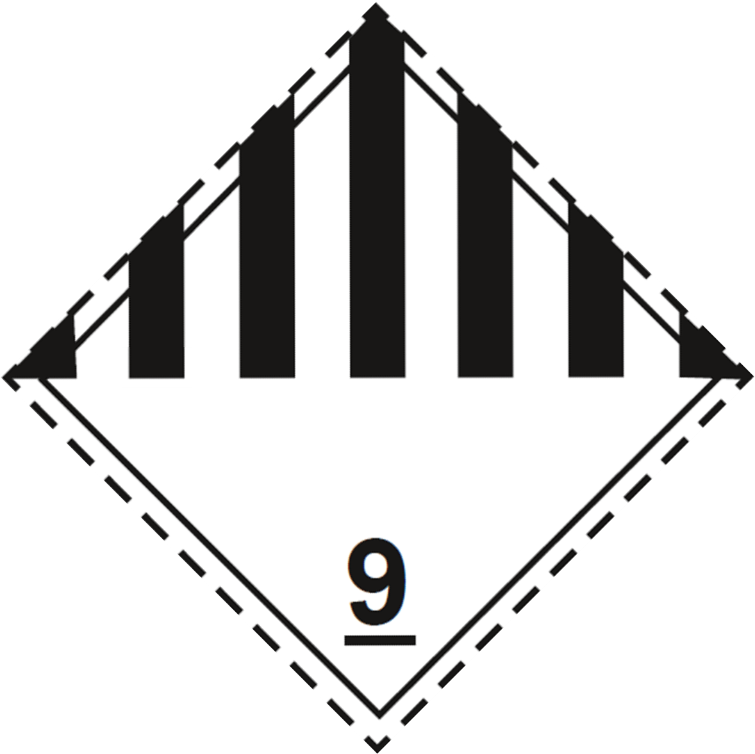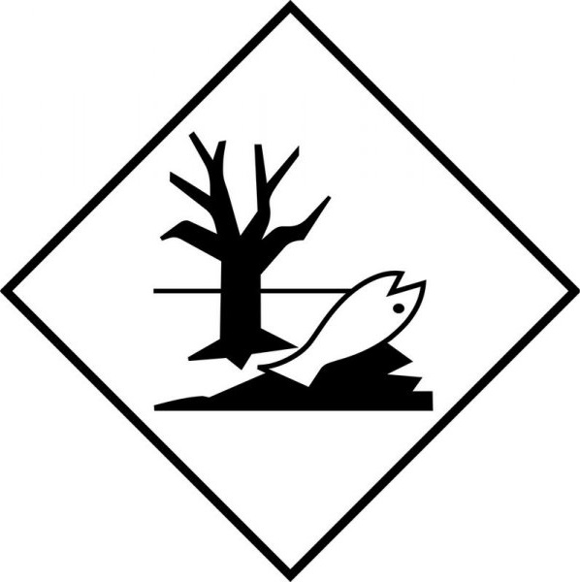
14.4. Packing group
III | III | III | III | III
14.5. Environmental hazards
Dangerous for the environment: Yes | Dangerous for the environment: Yes  Marine pollutant: Yes | Dangerous for the environment: Yes | Dangerous for the environment: Yes | Dangerous for the environment: Yes
No supplementary information available

14.6. Special precautions for user
Overland transport
Classification code (ADR) | : | M6
Special provisions (ADR) | : | 274, 335, 375, 601
Limited quantities (ADR) | : | 5l
Excepted quantities (ADR) | : | E1
Packing instructions (ADR) | : | P001, IBC03, LP01, R001
Special packing provisions (ADR) | : | PP1
Mixed packing provisions (ADR) | : | MP19
Portable tank and bulk container instructions (ADR) | : | T4
Portable tank and bulk container special provisions (ADR) | : | TP1, TP29
Tank code (ADR) | : | LGBV
Vehicle for tank carriage | : | AT
Transport category (ADR) | : | 3
Special provisions for carriage - Packages (ADR) | : | V12
Special provisions for carriage - Loading, unloading and handling (ADR) | : | CV13
Hazard identification number (Kemler No.) | : | 90
Orange plates | : | 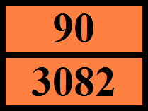
Tunnel restriction code (ADR) | : | -
EAC code | : | •3Z

Transport by sea
Special provisions (IMDG) | : | 274, 335, 969
Limited quantities (IMDG) | : | 5 L
Excepted quantities (IMDG) | : | E1
Packing instructions (IMDG) | : | LP01, P001
Special packing provisions (IMDG) | : | PP1
IBC packing instructions (IMDG) | : | IBC03
Tank instructions (IMDG) | : | T4
Tank special provisions (IMDG) | : | TP1, TP29
EmS-No. (Fire) | : | F-A
EmS-No. (Spillage) | : | S-F
Stowage category (IMDG) | : | A

Air transport
PCA Excepted quantities (IATA) | : | E1
PCA Limited quantities (IATA) | : | Y964
PCA limited quantity max net quantity (IATA) | : | 30kgG
PCA packing instructions (IATA) | : | 964
PCA max net quantity (IATA) | : | 450L
CAO packing instructions (IATA) | : | 964
CAO max net quantity (IATA) | : | 450L
Special provisions (IATA) | : | A97, A158, A197, A215
ERG code (IATA) | : | 9L

Inland waterway transport
Classification code (ADN) | : | M6
Special provisions (ADN) | : | 274, 335, 375, 601
Limited quantities (ADN) | : | 5 L
Excepted quantities (ADN) | : | E1
Carriage permitted (ADN) | : | T
Equipment required (ADN) | : | PP
Number of blue cones/lights (ADN) | : | 0

Rail transport
Classification code (RID) | : | M6
Special provisions (RID) | : | 274, 335, 375, 601
Limited quantities (RID) | : | 5L
Excepted quantities (RID) | : | E1
Packing instructions (RID) | : | P001, IBC03, LP01, R001
Special packing provisions (RID) | : | PP1
Mixed packing provisions (RID) | : | MP19
Portable tank and bulk container instructions (RID) | : | T4
Portable tank and bulk container special provisions (RID) | : | TP1, TP29
Tank codes for RID tanks (RID) | : | LGBV
Transport category (RID) | : | 3
Special provisions for carriage – Packages (RID) | : | W12
Special provisions for carriage - Loading, unloading and handling (RID) | : | CW13, CW31
Colis express (express parcels) (RID) | : | CE8
Hazard identification number (RID) | : | 90

14.7. Maritime transport in bulk according to IMO instruments
Not applicable

SECTION 15: Regulatory information

15.1. Safety, health and environmental regulations/legislation specific for the substance or mixture

15.1.1. EU-Regulations

REACH Annex XVII (Restriction List)
EU restriction list (REACH Annex XVII)
Reference code | Applicable on | Entry title or description
3(a) | Grapefruit oil ; Eucalyptus oil ; .alpha.-Pinene ; (R)-p-mentha-1,8-diene; d-limonene ; .beta.-Pinene ; p-Cymene | Substances or mixtures fulfilling the criteria for any of the following hazard classes or categories set out in Annex I to Regulation (EC) No 1272/2008: Hazard classes 2.1 to 2.4, 2.6 and 2.7, 2.8 types A and B, 2.9, 2.10, 2.12, 2.13 categories 1 and 2, 2.14 categories 1 and 2, 2.15 types A to F
3(b) | FRANKINCENSE & MYRRH #EU25961F 25% in DPG ; Iso E Super ; Dihydromyrcenol ; Clove Leaf Oil ; Eugenol ; Linalyl acetate ; Linalool ; Grapefruit oil ; Cinnamic aldehyde ; Cedarwood oil, Texas ; Eucalyptus oil ; Helional ; Patchouli oil ; citral ; (R)-p-mentha-1,8-diene; d-limonene ; p-Cymene | Substances or mixtures fulfilling the criteria for any of the following hazard classes or categories set out in Annex I to Regulation (EC) No 1272/2008: Hazard classes 3.1 to 3.6, 3.7 adverse effects on sexual function and fertility or on development, 3.8 effects other than narcotic effects, 3.9 and 3.10
3(c) | FRANKINCENSE & MYRRH #EU25961F 25% in DPG ; Iso E Super ; 1-[(2-tert-butyl)cyclohexyloxy]-2-butanol ; 1,3,4,6,7,8-hexahydro-4,6,6,7,8,8-hexamethylindeno[5,6-c]pyran; galaxolide; (HHCB) ; Grapefruit oil ; Cinnamic aldehyde ; Cedarwood oil, Texas ; Eucalyptus oil ; Helional ; Patchouli oil ; (R)-p-mentha-1,8-diene; d-limonene ; p-Cymene | Substances or mixtures fulfilling the criteria for any of the following hazard classes or categories set out in Annex I to Regulation (EC) No 1272/2008: Hazard class 4.1
40. | Grapefruit oil ; Eucalyptus oil ; .alpha.-Pinene ; (R)-p-mentha-1,8-diene; d-limonene ; .beta.-Pinene ; p-Cymene | Substances classified as flammable gases category 1 or 2, flammable liquids categories 1, 2 or 3, flammable solids category 1 or 2, substances and mixtures which, in contact with water, emit flammable gases, category 1, 2 or 3, pyrophoric liquids category 1 or pyrophoric solids category 1, regardless of whether they appear in Part 3 of Annex VI to Regulation (EC) No 1272/2008 or not.

REACH Annex XIV (Authorisation List)
Contains no substance(s) listed on REACH Annex XIV (Authorisation List)

REACH Candidate List (SVHC)
Contains no substance(s) listed on the REACH Candidate List

PIC Regulation (Prior Informed Consent)
Contains no substance(s) listed on the PIC list (Regulation EU 649/2012 concerning the export and import of hazardous chemicals)

POP Regulation (Persistent Organic Pollutants)
Contains no substance(s) listed on the POP list (Regulation EU 2019/1021 on persistent organic pollutants)

Ozone Regulation (1005/2009)
Contains no substance(s) listed on the Ozone Depletion list (Regulation EU 1005/2009 on substances that deplete the ozone layer)

Explosives Precursors Regulation (2019/1148)
Contains no substance(s) listed on the Explosives Precursors list (Regulation EU 2019/1148 on the marketing and use of explosives precursors)

Drug Precursors Regulation (273/2004)
Contains no substance(s) listed on the Drug Precursors list (Regulation EC 273/2004 on the manufacture and the placing on market of certain substances used in the illicit manufacture of narcotic drugs and psychotropic substances)

15.1.2. National regulations

Germany
Employment restrictions | : | Observe restrictions according Act on the Protection of Working Mothers (MuSchG).  Observe restrictions according Act on the Protection of Young People in Employment (JArbSchG).
Water hazard class (WGK) | : | WGK 2, Significantly hazardous to water (Classification according to AwSV, Annex 1).
Storage class (LGK, TRGS 510) | : | LGK 12 - Non-combustible liquids.
Joint storage table | : | 
Joint storage not permitted for | : | LGK 1, LGK 6.2, LGK 7.
Joint storage with restrictions permitted for | : | LGK 4.1A, LGK 4.3, LGK 5.1C.
Joint storage permitted for | : | LGK 2A, LGK 2B, LGK 3, LGK 4.1B, LGK 4.2, LGK 5.1A, LGK 5.1B, LGK 5.2, LGK 6.1A, LGK 6.1B, LGK 6.1C, LGK 6.1D, LGK 8A, LGK 8B, LGK 10, LGK 11, LGK 12, LGK 13, LGK 10-13.
List of sensitizing substances (TRGS 907) | : | Contains sensitizing substances according TRGS 907.
Hazardous Incident Ordinance (12. BImSchV) | : | Is not subject of the Hazardous Incident Ordinance (12. BImSchV)

Netherlands
ABM category | : | A(2) - toxic for aquatic organisms, may have longterm hazardous effects in aquatic environment
SZW-lijst van kankerverwekkende stoffen | : | Cedarwood oil, Texas,Eucalyptus oil are listed
SZW-lijst van mutagene stoffen | : | Eucalyptus oil is listed
SZW-lijst van reprotoxische stoffen – Borstvoeding | : | None of the components are listed
SZW-lijst van reprotoxische stoffen – Vruchtbaarheid | : | None of the components are listed
SZW-lijst van reprotoxische stoffen – Ontwikkeling | : | None of the components are listed

Denmark
Classification remarks | : | Emergency management guidelines for the storage of flammable liquids must be followed
Danish National Regulations | : | Young people below the age of 18 years are not allowed to use the product  Pregnant/breastfeeding women working with the product must not be in direct contact with the product

Switzerland
Storage class (LK) | : | LK 10/12 - Liquids

15.2. Chemical safety assessment
No chemical safety assessment has been carried out

SECTION 16: Other information
Data sources | : | REGULATION (EC) No 1272/2008 OF THE EUROPEAN PARLIAMENT AND OF THE COUNCIL of 16 December 2008 on classification, labelling and packaging of substances and mixtures, amending and repealing Directives 67/548/EEC and 1999/45/EC, and amending Regulation (EC) No 1907/2006.
Other information | : | None.

Full text of H- and EUH-statements:
Acute Tox. 3 (Inhalation) | Acute toxicity (inhal.), Category 3
Acute Tox. 3 (Inhalation:dust,mist) | Acute toxicity (inhalation:dust,mist) Category 3
Acute Tox. 4 (Dermal) | Acute toxicity (dermal), Category 4
Acute Tox. 4 (Oral) | Acute toxicity (oral), Category 4
Aquatic Acute 1 | Hazardous to the aquatic environment – Acute Hazard, Category 1
Aquatic Chronic 1 | Hazardous to the aquatic environment – Chronic Hazard, Category 1
Aquatic Chronic 2 | Hazardous to the aquatic environment – Chronic Hazard, Category 2
Aquatic Chronic 3 | Hazardous to the aquatic environment – Chronic Hazard, Category 3
Asp. Tox. 1 | Aspiration hazard, Category 1
Eye Irrit. 2 | Serious eye damage/eye irritation, Category 2
Flam. Liq. 3 | Flammable liquids, Category 3
H226 | Flammable liquid and vapour.
H302 | Harmful if swallowed.
H304 | May be fatal if swallowed and enters airways.
H312 | Harmful in contact with skin.
H315 | Causes skin irritation.
H317 | May cause an allergic skin reaction.
H319 | Causes serious eye irritation.
H331 | Toxic if inhaled.
H361 | Suspected of damaging fertility or the unborn child.
H400 | Very toxic to aquatic life.
H410 | Very toxic to aquatic life with long lasting effects.
H411 | Toxic to aquatic life with long lasting effects.
H412 | Harmful to aquatic life with long lasting effects.
Repr. 2 | Reproductive toxicity, Category 2
Skin Irrit. 2 | Skin corrosion/irritation, Category 2
Skin Sens. 1 | Skin sensitisation, Category 1
Skin Sens. 1A | Skin sensitisation, category 1A
Skin Sens. 1B | Skin sensitisation, category 1B

The classification complies with | : | ATP 12
Safety Data Sheet (SDS), EU
This information is based on our current knowledge and is intended to describe the product for the purposes of health, safety and environmental requirements only. It should not therefore be construed as guaranteeing any specific property of the product.

