SECTION 1: Identification of the substance/mixture and of the company/undertaking

1.1. Product identifier
Product form | : | Mixture
Product name | : | Honey Blossom #EU27295F 25%
Product code | : | EU27295F_25%
Type of product | : | Perfumes, Fragrances
Product group | : | Trade product

1.2. Relevant identified uses of the substance or mixture and uses advised against

1.2.1. Relevant identified uses
Main use category | : | Professional use,Industrial use
Industrial/Professional use spec | : | Industrial  For professional use only
Use of the substance/mixture | : | Perfumes, Fragrances
Function or use category | : | Odour agents

1.2.2. Uses advised against
No additional information available

1.3. Details of the supplier of the safety data sheet
No additional information available

1.4. Emergency telephone number
No additional information available

SECTION 2: Hazards identification

2.1. Classification of the substance or mixture

Classification according to Regulation (EC) No. 1272/2008 [CLP]
Skin sensitization, Category 1 | H317
Hazardous to the aquatic environment – Chronic Hazard Category 2 | H411
Full text of H- and EUH-statements: see section 16

Adverse physicochemical, human health and environmental effects
Toxic to aquatic life with long lasting effects. May cause an allergic skin reaction.

2.2. Label elements

Labeling according to Regulation (EC) No. 1272/2008 [CLP]
Hazard pictograms (CLP) | : | 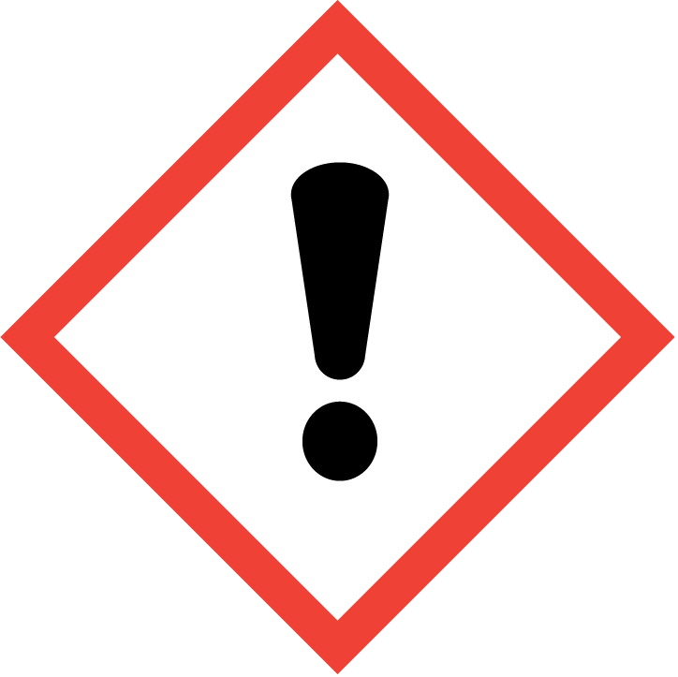 | 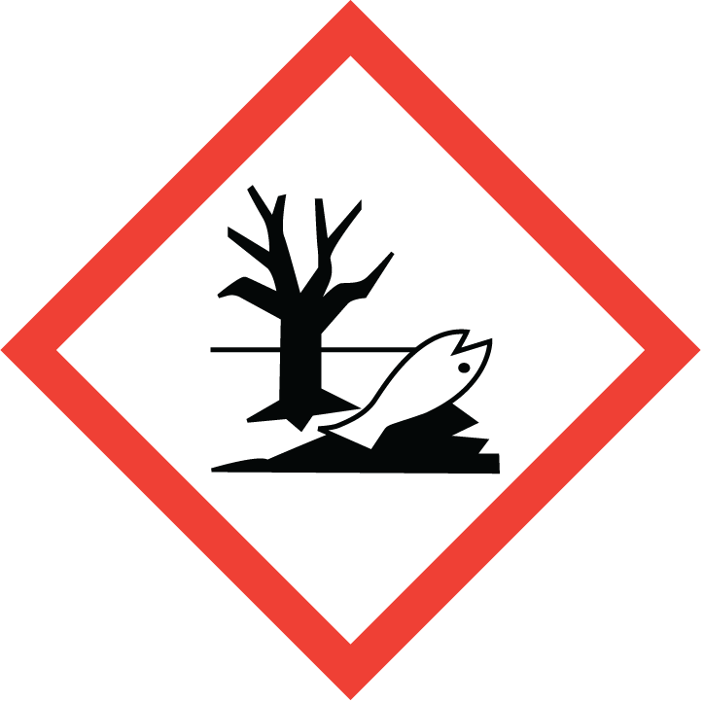
 |  | GHS07 | GHS09
Signal word (CLP) | : | Warning
Contains | : | Iso E Super; Hexyl cinnamic aldehyde; Linalool; Aldehyde C-16; Patchouli oil; COUMARIN
Hazard statements (CLP) | : | H317 - May cause an allergic skin reaction.  H411 - Toxic to aquatic life with long lasting effects.
Precautionary statements (CLP) | : | P261 - Avoid breathing dust/fume/gas/mist/vapors/spray.  P272 - Contaminated work clothing should not be allowed out of the workplace.  P273 - Avoid release to the environment.  P280 - Wear protective gloves/protective clothing/eye protection/face protection/hearing protection.  P302+P352 - IF ON SKIN: Wash with plenty of water.  P321 - Specific treatment (see supplemental first aid instruction on this label).

2.3. Other hazards
Contains no PBT/vPvB substances ≥ 0.1% assessed in accordance with REACH Annex XIII

The mixture does not contain substance(s) included in the list established in accordance with Article 59(1) of REACH for having endocrine disrupting properties, or is not identified as having endocrine disrupting properties in accordance with the criteria set out in Commission Delegated Regulation (EU) 2017/2100 or Commission Regulation (EU) 2018/605 at a concentration equal to or greater than 0,1 %

SECTION 3: Composition/Information on ingredients

3.1. Substances
Not applicable

3.2. Mixtures
Name | Product identifier | % | Classification according to Regulation (EC) No. 1272/2008 [CLP]
benzyl benzoate | CAS-No.: 120-51-4  EC-No.: 204-402-9  EC Index-No.: 607-085-00-9  REACH-no: 01-2119976371-33 | 2.675 – 5.35 | Acute Tox. 4 (Oral), H302  Aquatic Acute 1, H400  Aquatic Chronic 2, H411
Iso E Super | CAS-No.: 54464-57-2  EC-No.: 259-174-3  REACH-no: 01-2119489989-04 | 1.5 – 3 | Skin Irrit. 2, H315  Skin Sens. 1, H317  Aquatic Chronic 1, H410
Hexyl cinnamic aldehyde | CAS-No.: 101-86-0  EC-No.: 202-983-3  REACH-no: 01-2119533092-50 | 1.4 – 2.8 | Skin Sens. 1, H317  Aquatic Chronic 2, H411
tetrahydro-2-isobutyl-4-methylpyran-4-ol, mixed isomers (cis and trans) | CAS-No.: 63500-71-0  EC-No.: 405-040-6  EC Index-No.: 603-101-00-3  REACH-no: 01-000015458-64 | 0.696875 – 2.7875 | Eye Irrit. 2, H319
Ethyl vanillin | CAS-No.: 121-32-4  EC-No.: 204-464-7  REACH-no: 01-211958961-24 | 0.53125 – 1.0625 | Eye Irrit. 2, H319
1,3,4,6,7,8-hexahydro-4,6,6,7,8,8-hexamethylindeno[5,6-c]pyran, galaxolide, (HHCB) | CAS-No.: 1222-05-5  EC-No.: 214-946-9  EC Index-No.: 603-212-00-7  REACH-no: 01-2119488227-29 | 0.485 – 0.97 | Aquatic Acute 1, H400  Aquatic Chronic 1, H410
Linalool | CAS-No.: 78-70-6  EC-No.: 201-134-4  EC Index-No.: 603-235-00-2  REACH-no: 01-2119474016-42 | 0.4 – 0.8 | Skin Irrit. 2, H315  Eye Irrit. 2, H319  Skin Sens. 1B, H317
Aldehyde C-16 | CAS-No.: 77-83-8  EC-No.: 201-061-8  REACH-no: 01-2119967770-28 | 0.15 – 0.3 | Skin Sens. 1B, H317  Aquatic Chronic 2, H411
Patchouli oil | CAS-No.: 8014-09-3  EC Index-No.: 616-944-7 | 0.075 – 0.15 | Skin Sens. 1B, H317  Asp. Tox. 1, H304  Aquatic Chronic 2, H411
COUMARIN | CAS-No.: 91-64-5  EC-No.: 202-086-7  REACH-no: 01-2119943756-26 | 0.06875 – 0.1375 | Acute Tox. 3 (Oral), H301  Acute Tox. 3 (Dermal), H311  Acute Tox. 3 (Inhalation), H331  Skin Sens. 1, H317  Aquatic Chronic 2, H411
Benzyl acetate  substance with national workplace exposure limit(s) (BE, DK, ES, IE, LT, LV, PT, RO) | CAS-No.: 140-11-4  EC-No.: 205-399-7  REACH-no: 01-2119638272-42 | 0.04375 – 0.0875 | Aquatic Chronic 3, H412
Full text of H- and EUH-statements: see section 16

SECTION 4: First aid measures

4.1. Description of first aid measures
First-aid measures general | : | Never give anything by mouth to an unconscious person. If you feel unwell, seek medical advice (show the label where possible).
First-aid measures after inhalation | : | Remove person to fresh air and keep comfortable for breathing. Allow affected person to breathe fresh air. Allow the victim to rest.
First-aid measures after skin contact | : | Remove affected clothing and wash all exposed skin area with mild soap and water, followed by warm water rinse. Wash skin with plenty of water. Take off contaminated clothing. If skin irritation or rash occurs: Get medical advice/attention.
First-aid measures after eye contact | : | Rinse immediately with plenty of water. Obtain medical attention if pain, blinking or redness persists. Rinse eyes with water as a precaution.
First-aid measures after ingestion | : | Rinse mouth. Do NOT induce vomiting. Obtain emergency medical attention. Call a poison center/doctor/physician if you feel unwell.

4.2. Most important symptoms and effects, both acute and delayed
Symptoms/effects | : | Not expected to present a significant hazard under anticipated conditions of normal use.
Symptoms/effects after skin contact | : | May cause an allergic skin reaction.

4.3. Indication of any immediate medical attention and special treatment needed
Treat symptomatically.

SECTION 5: Firefighting measures

5.1. Extinguishing media
Suitable extinguishing media | : | Foam. Dry powder. Carbon dioxide. Water spray. Sand.
Unsuitable extinguishing media | : | Do not use a heavy water stream.

5.2. Special hazards arising from the substance or mixture
Hazardous decomposition products in case of fire | : | Toxic fumes may be released.

5.3. Advice for firefighters
Firefighting instructions | : | Use water spray or fog for cooling exposed containers. Exercise caution when fighting any chemical fire. Prevent fire-fighting water from entering environment.
Protection during firefighting | : | Do not enter fire area without proper protective equipment, including respiratory protection. Do not attempt to take action without suitable protective equipment. Self-contained breathing apparatus. Complete protective clothing.

SECTION 6: Accidental release measures

6.1. Personal precautions, protective equipment and emergency procedures

6.1.1. For non-emergency personnel
Emergency procedures | : | Ventilate spillage area. Evacuate unnecessary personnel. Avoid contact with skin and eyes. Avoid breathing dust/fume/gas/mist/vapors/spray.

6.1.2. For emergency responders
Protective equipment | : | Do not attempt to take action without suitable protective equipment. Equip cleanup crew with proper protection. For further information refer to section 8: "Exposure controls/personal protection".
Emergency procedures | : | Ventilate area.

6.2. Environmental precautions
Avoid release to the environment. Prevent entry to sewers and public waters. Notify authorities if liquid enters sewers or public waters.

6.3. Methods and material for containment and cleaning up
For containment | : | Collect spillage.
Methods for cleaning up | : | Take up liquid spill into absorbent material. Soak up spills with inert solids, such as clay or diatomaceous earth as soon as possible. Collect spillage. Store away from other materials.
Other information | : | Dispose of materials or solid residues at an authorized site.

6.4. Reference to other sections
See Heading 8. Exposure controls and personal protection. For further information refer to section 13.

SECTION 7: Handling and storage

7.1. Precautions for safe handling
Precautions for safe handling | : | Ensure good ventilation of the work station. Wash hands and other exposed areas with mild soap and water before eating, drinking or smoking and when leaving work. Provide good ventilation in process area to prevent formation of vapor. Avoid contact with skin and eyes. Avoid breathing dust/fume/gas/mist/vapors/spray. Wear personal protective equipment.
Hygiene measures | : | Contaminated work clothing should not be allowed out of the workplace. Wash contaminated clothing before reuse. Do not eat, drink or smoke when using this product. Always wash hands after handling the product.

7.2. Conditions for safe storage, including any incompatibilities
Storage conditions | : | Keep only in the original container in a cool, well ventilated place away from : Keep container closed when not in use. Store in a well-ventilated place. Keep cool.
Incompatible products | : | Strong bases. Strong acids.
Incompatible materials | : | Sources of ignition. Direct sunlight.
Storage temperature | : | 25 °C
Storage area | : | Store in a well-ventilated place. Store away from heat.
Special rules on packaging | : | Store in a closed container.
Packaging materials | : | Do not store in corrodable metal.

7.3. Specific end use(s)
No additional information available

SECTION 8: Exposure controls/personal protection

8.1. Control parameters

8.1.1 National occupational exposure and biological limit values

Benzyl acetate (140-11-4)
Belgium - Occupational Exposure Limits
OEL TWA | 62 mg/m³
OEL TWA | 10 ppm
Denmark - Occupational Exposure Limits
OEL TWA [1] | 61 mg/m³
OEL TWA [2] | 10 ppm
OEL STEL | 122 mg/m³
OEL STEL | 20 ppm
Ireland - Occupational Exposure Limits
OEL TWA [2] | 10 ppm
OEL STEL | 30 ppm (calculated)
Latvia - Occupational Exposure Limits
OEL TWA | 5 mg/m³
Lithuania - Occupational Exposure Limits
IPRV (OEL TWA) | 5 mg/m³
Portugal - Occupational Exposure Limits
OEL TWA | 10 ppm
OEL chemical category | A4 - Not Classifiable as a Human Carcinogen
Romania - Occupational Exposure Limits
OEL TWA | 50 mg/m³
OEL TWA | 8 ppm
OEL STEL | 80 mg/m³
OEL STEL | 13 ppm
Spain - Occupational Exposure Limits
VLA-ED (OEL TWA) [1] | 62 mg/m³
VLA-ED (OEL TWA) [2] | 10 ppm
USA - ACGIH - Occupational Exposure Limits
ACGIH OEL TWA [ppm] | 10 ppm
ACGIH chemical category | Not Classifiable as a Human Carcinogen

8.1.2. Recommended monitoring procedures
No additional information available

8.1.3. Air contaminants formed
No additional information available

8.1.4. DNEL and PNEC
No additional information available

8.1.5. Control banding
No additional information available

8.2. Exposure controls

8.2.1. Appropriate engineering controls
Appropriate engineering controls:
Ensure good ventilation of the work station.

8.2.2. Personal protection equipment
Personal protective equipment:
Avoid all unnecessary exposure.
Personal protective equipment symbol(s):


8.2.2.1. Eye and face protection
Eye protection:
Chemical goggles or safety glasses. Safety glasses

8.2.2.2. Skin protection
Skin and body protection:
Wear suitable protective clothing

Hand protection:
Wear protective gloves.

8.2.2.3. Respiratory protection
Respiratory protection:
Wear appropriate mask

8.2.2.4. Thermal hazards
No additional information available

8.2.3. Environmental exposure controls
Environmental exposure controls:
Avoid release to the environment.
Other information:
Do not eat, drink or smoke during use.

SECTION 9: Physical and chemical properties

9.1. Information on basic physical and chemical properties
Physical state | : | Liquid
Color | : | Standard. light yellow. amber. Conforms to standard.
Odor | : | characteristic.
Odor threshold | : | Not available
Melting point | : | Not applicable
Freezing point | : | Not available
Boiling point | : | Not available
Flammability | : | Non flammable.
Explosion limits | : | Not available
Lower explosion limit | : | Not available
Upper explosion limit | : | Not available
Flash point | : | > 93 °C
Auto-ignition temperature | : | Not available
Decomposition temperature | : | Not available
pH | : | Not available
Viscosity, kinematic | : | Not available
Solubility | : | Not available
Partition coefficient n-octanol/water (Log Kow) | : | Not available
Vapor pressure | : | Not available
Vapor pressure at 50°C | : | Not available
Density | : | Not available
Relative density | : | Not available
Relative vapor density at 20°C | : | Not available
Particle characteristics | : | Not applicable

9.2. Other information

9.2.1. Information with regard to physical hazard classes
No additional information available

9.2.2. Other safety characteristics
No additional information available

SECTION 10: Stability and reactivity

10.1. Reactivity
The product is non-reactive under normal conditions of use, storage and transport.

10.2. Chemical stability
Not established.

10.3. Possibility of hazardous reactions
Not established.

10.4. Conditions to avoid
Direct sunlight. Extremely high or low temperatures.

10.5. Incompatible materials
Strong acids. Strong bases.

10.6. Hazardous decomposition products
fume. Carbon monoxide. Carbon dioxide.

SECTION 11: Toxicological information

11.1. Information on hazard classes as defined in Regulation (EC) No 1272/2008
Acute toxicity (oral) | : | Not classified
Acute toxicity (dermal) | : | Not classified
Acute toxicity (inhalation) | : | Not classified

benzyl benzoate (120-51-4)
LD50 oral rat | 500 mg/kg (Source: NLM_CIP)
LD50 oral | 1160 mg/kg body weight
LD50 dermal rabbit | 4000 mg/kg (Source: NLM_CIP)

Hexyl cinnamic aldehyde (101-86-0)
LD50 oral rat | 3100 mg/kg (Source: NLM_CIP)
LD50 oral | 3100 mg/kg body weight
LD50 dermal rabbit | > 3000 mg/kg (Source: EPA_HPV)
LC50 Inhalation - Rat | > 5 mg/l/4h

tetrahydro-2-isobutyl-4-methylpyran-4-ol, mixed isomers (cis and trans) (63500-71-0)
LD50 dermal rabbit | > 2000 mg/kg (Source: ECHA_API)

Ethyl vanillin (121-32-4)
LD50 oral rat | 1590 mg/kg (Source: NLM_CIP)
LD50 oral | 3000 mg/kg body weight
LD50 dermal rat | > 2000 mg/kg (Source: ECHA_API)

1,3,4,6,7,8-hexahydro-4,6,6,7,8,8-hexamethylindeno[5,6-c]pyran, galaxolide, (HHCB) (1222-05-5)
LD50 oral rat | > 3250 mg/kg (Source: CHEMVIEW)
LD50 dermal rabbit | > 3250 mg/kg (Source: CHEMVIEW)

Linalool (78-70-6)
LD50 oral | 2790 mg/kg body weight

Aldehyde C-16 (77-83-8)
LD50 oral rat | 5470 mg/kg (Source: NLM_CIP)
LD50 dermal rat | > 2000 mg/kg (Source: ECHA_API)

Patchouli oil (8014-09-3)
LD50 oral rat | > 5 g/kg (Source: NLM_CIP)

COUMARIN (91-64-5)
LD50 oral rat | > 5000 mg/kg (Source: JAPAN_GHS)
LD50 oral | 290 mg/kg body weight
LD50 dermal rat | 293 mg/kg (Source: ECHA_API)

Benzyl acetate (140-11-4)
LD50 oral rat | 2490 mg/kg (Source: JAPAN_GHS)
LD50 oral | 2490 mg/kg body weight
LD50 dermal rabbit | > 5000 mg/kg (Source: JAPAN_GHS)

Skin corrosion/irritation | : | Not classified
Additional information | : | Based on available data, the classification criteria are not met

Serious eye damage/irritation | : | Not classified
Additional information | : | Based on available data, the classification criteria are not met

Respiratory or skin sensitization | : | May cause an allergic skin reaction.
Additional information | : | Based on available data, the classification criteria are not met

Germ cell mutagenicity | : | Not classified
Additional information | : | Based on available data, the classification criteria are not met

Carcinogenicity | : | Not classified
Additional information | : | Based on available data, the classification criteria are not met

COUMARIN (91-64-5)
IARC group | 3 - Not classifiable

Benzyl acetate (140-11-4)
IARC group | 3 - Not classifiable

Reproductive toxicity | : | Not classified
Additional information | : | Based on available data, the classification criteria are not met

STOT-single exposure | : | Not classified
Additional information | : | Based on available data, the classification criteria are not met

STOT-repeated exposure | : | Not classified
Additional information | : | Based on available data, the classification criteria are not met

Aspiration hazard | : | Not classified
Additional information | : | Based on available data, the classification criteria are not met

benzyl benzoate (120-51-4)
Viscosity, kinematic | 7.456 mm²/s

11.2. Information on other hazards

11.2.1. Endocrine disrupting properties
No additional information available

11.2.2. Other information
Potential Adverse human health effects and symptoms | : | Based on available data, the classification criteria are not met

SECTION 12: Ecological information

12.1. Toxicity
Ecology - general | : | Toxic to aquatic life with long lasting effects.
Hazardous to the aquatic environment, short–term (acute) | : | Not classified
Hazardous to the aquatic environment, long–term (chronic) | : | Toxic to aquatic life with long lasting effects.

benzyl benzoate (120-51-4)
LC50 - Fish [1] | 2.32 mg/l (Exposure time: 96 h - Species: Danio rerio [semi-static] Source: ECHA)
NOEC (chronic) | 0.168 mg/l

Ethyl vanillin (121-32-4)
LC50 - Fish [1] | 81.4 – 94.3 mg/l (Exposure time: 96 h - Species: Pimephales promelas [flow-through] Source: EPA)

1,3,4,6,7,8-hexahydro-4,6,6,7,8,8-hexamethylindeno[5,6-c]pyran, galaxolide, (HHCB) (1222-05-5)
LC50 - Fish [1] | 0.452 mg/l Wolf, 1996d-27682
LC50 - Other aquatic organisms [1] | > 0.14 mg/l REACH DOSSIER Pimephales promelas
EC50 - Crustacea [2] | 260 μg/l REACH Dossier
EC50 - Other aquatic organisms [1] | 0.131 mg/l REACH Dossier

Linalool (78-70-6)
EC50 96h - Algae [1] | 88.3 mg/l (Species: Desmodesmus subspicatus)

Aldehyde C-16 (77-83-8)
LC50 - Fish [1] | 4.2 mg/l (Exposure time: 96 h - Species: Oncorhynchus mykiss [semi-static] Source: ECHA)

12.2. Persistence and degradability
Honey Blossom #EU27295F 25%
Persistence and degradability | Not established.

benzyl benzoate (120-51-4)
Persistence and degradability | May cause long-term adverse effects in the environment.

12.3. Bioaccumulative potential
Honey Blossom #EU27295F 25%
Bioaccumulative potential | Not established.

benzyl benzoate (120-51-4)
Partition coefficient n-octanol/water (Log Pow) | 3.97 (at 25 °C)
Bioaccumulative potential | Not established.

tetrahydro-2-isobutyl-4-methylpyran-4-ol, mixed isomers (cis and trans) (63500-71-0)
Partition coefficient n-octanol/water (Log Pow) | 1.65 (at 23 °C (at pH >6.09-<6.74)

Ethyl vanillin (121-32-4)
Partition coefficient n-octanol/water (Log Pow) | 1.61 (at 25 °C)

1,3,4,6,7,8-hexahydro-4,6,6,7,8,8-hexamethylindeno[5,6-c]pyran, galaxolide, (HHCB) (1222-05-5)
BCF - Fish [1] | (1618 dimensionless (whole body w.w.)
Partition coefficient n-octanol/water (Log Pow) | 5.3 (at 25 °C (at pH 7)

Aldehyde C-16 (77-83-8)
Partition coefficient n-octanol/water (Log Pow) | 2.4 (at 25 °C (cis isomer)

Benzyl acetate (140-11-4)
Partition coefficient n-octanol/water (Log Pow) | 1.96 (at 25 °C (at pH 7)

12.4. Mobility in soil
No additional information available

12.5. Results of PBT and vPvB assessment
No additional information available

12.6. Endocrine disrupting properties
No additional information available

12.7. Other adverse effects
Additional information | : | Avoid release to the environment.

SECTION 13: Disposal considerations

13.1. Waste treatment methods
Waste treatment methods | : | Dispose of contents/container in accordance with licensed collector’s sorting instructions.
Product/Packaging disposal recommendations | : | Dispose in a safe manner in accordance with local/national regulations.
Ecology - waste materials | : | Avoid release to the environment.
HP code | : | HP14 - “Ecotoxic:” waste which presents or may present immediate or delayed risks for one or more sectors of the environment

SECTION 14: Transport information
In accordance with ADR / IMDG / IATA / ADN / RID
ADR | IMDG | IATA | ADN | RID
14.1. UN number or ID number
UN 3082 | UN 3082 | UN 3082 | UN 3082 | UN 3082
14.2. UN proper shipping name
ENVIRONMENTALLY HAZARDOUS SUBSTANCE, LIQUID, N.O.S. (ISO E SUPER) | ENVIRONMENTALLY HAZARDOUS SUBSTANCE, LIQUID, N.O.S. (ISO E SUPER) | Environmentally hazardous substance, liquid, n.o.s. (ISO E SUPER) | ENVIRONMENTALLY HAZARDOUS SUBSTANCE, LIQUID, N.O.S. (ISO E SUPER) | ENVIRONMENTALLY HAZARDOUS SUBSTANCE, LIQUID, N.O.S. (ISO E SUPER)
Transport document description
UN 3082 ENVIRONMENTALLY HAZARDOUS SUBSTANCE, LIQUID, N.O.S. (ISO E SUPER), 9, III, (-) | UN 3082 ENVIRONMENTALLY HAZARDOUS SUBSTANCE, LIQUID, N.O.S. (ISO E SUPER), 9, III, MARINE POLLUTANT | UN 3082 Environmentally hazardous substance, liquid, n.o.s. (ISO E SUPER), 9, III | UN 3082 ENVIRONMENTALLY HAZARDOUS SUBSTANCE, LIQUID, N.O.S. (ISO E SUPER), 9, III | UN 3082 ENVIRONMENTALLY HAZARDOUS SUBSTANCE, LIQUID, N.O.S. (ISO E SUPER), 9, III
14.3. Transport hazard class(es)
9 | 9 | 9 | 9 | 9
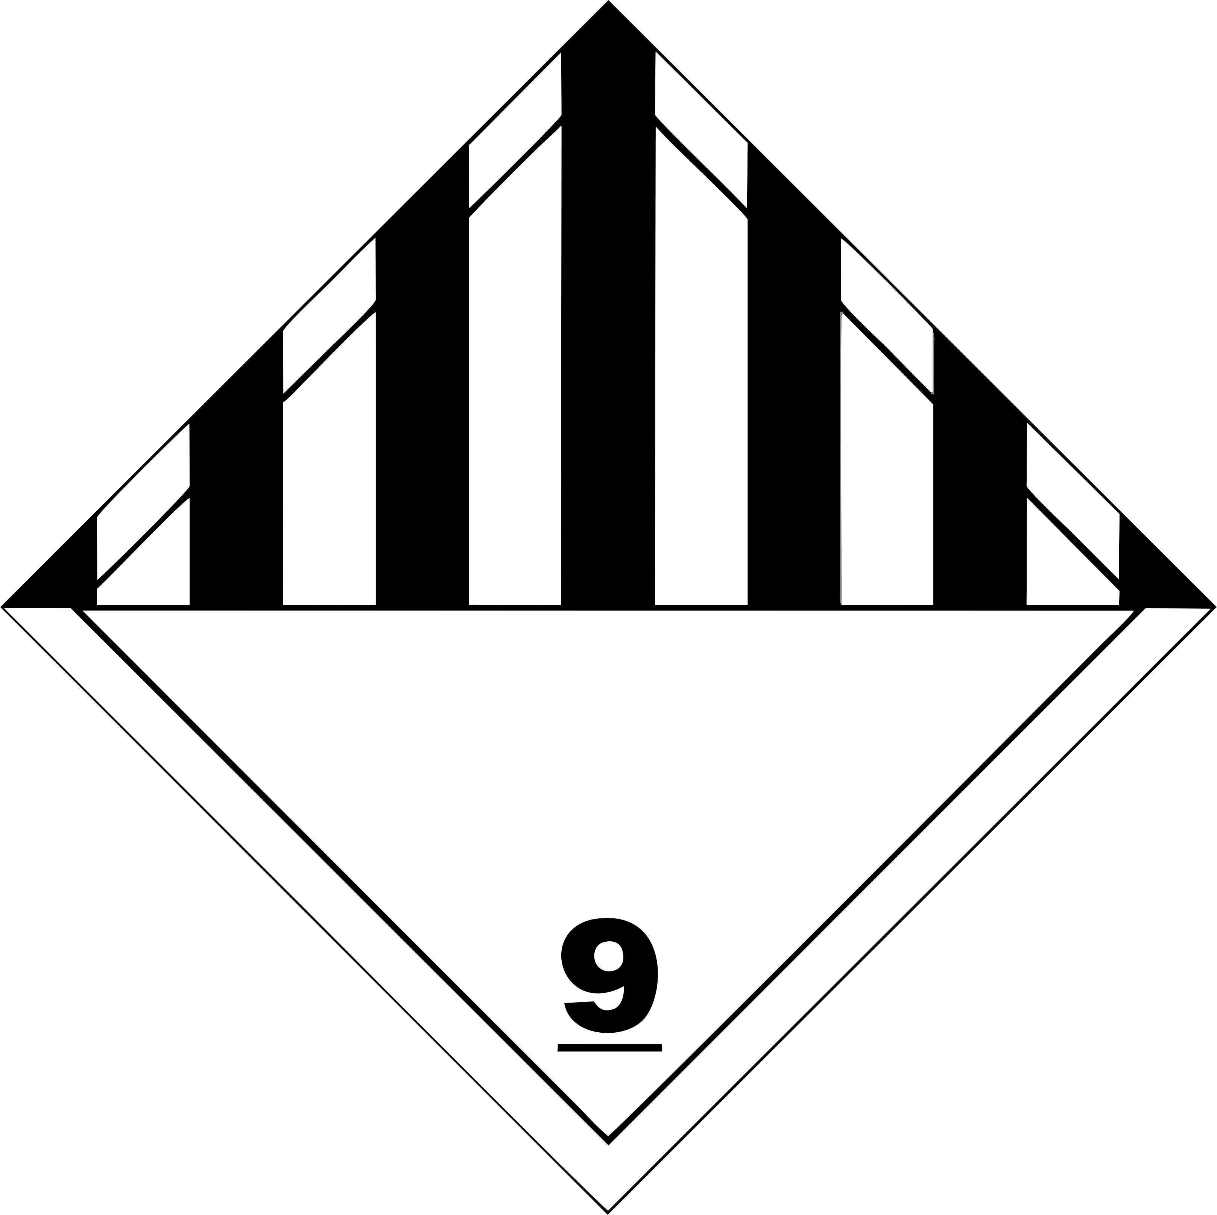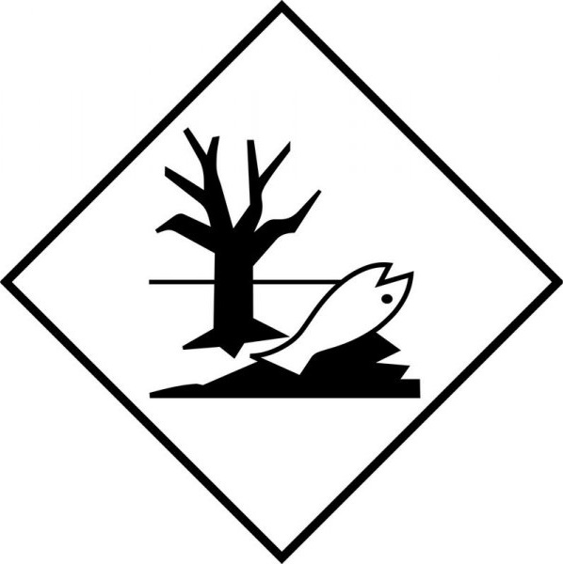
14.4. Packing group
III | III | III | III | III
14.5. Environmental hazards
Dangerous for the environment: Yes | Dangerous for the environment: Yes  Marine pollutant: Yes | Dangerous for the environment: Yes | Dangerous for the environment: Yes | Dangerous for the environment: Yes
No supplementary information available

14.6. Special precautions for user
Overland transport
Classification code (ADR) | : | M6
Special provision (ADR) | : | 274, 335, 375, 601
Limited quantities (ADR) | : | 5l
Excepted quantities (ADR) | : | E1
Packing instructions (ADR) | : | P001, IBC03, LP01, R001
Special packing provisions (ADR) | : | PP1
Mixed packing provisions (ADR) | : | MP19
Portable tank and bulk container instructions (ADR) | : | T4
Portable tank and bulk container special provisions (ADR) | : | TP1, TP29
Tank code (ADR) | : | LGBV
Vehicle for tank carriage | : | AT
Transport category (ADR) | : | 3
Special provisions for carriage - Packages (ADR) | : | V12
Special provisions for carriage - Loading, unloading and handling (ADR) | : | CV13
Hazard identification number (Kemler No.) | : | 90
Orange plates | : | 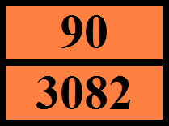
Tunnel restriction code (ADR) | : | -
EAC | : | •3Z

Transport by sea
Special provision (IMDG) | : | 274, 335, 969
Limited quantities (IMDG) | : | 5 L
Excepted quantities (IMDG) | : | E1
Packing instructions (IMDG) | : | LP01, P001
Packing provisions (IMDG) | : | PP1
IBC packing instructions (IMDG) | : | IBC03
Tank instructions (IMDG) | : | T4
Tank special provisions (IMDG) | : | TP1, TP29
EmS-No. (Fire) | : | F-A
EmS-No. (Spillage) | : | S-F
Stowage category (IMDG) | : | A

Air transport
PCA Excepted quantities (IATA) | : | E1
PCA Limited quantities (IATA) | : | Y964
PCA limited quantity max net quantity (IATA) | : | 30kgG
PCA packing instructions (IATA) | : | 964
PCA max net quantity (IATA) | : | 450L
CAO packing instructions (IATA) | : | 964
CAO max net quantity (IATA) | : | 450L
Special provision (IATA) | : | A97, A158, A197, A215
ERG code (IATA) | : | 9L

Inland waterway transport
Classification code (ADN) | : | M6
Special provision (ADN) | : | 274, 335, 375, 601
Limited quantities (ADN) | : | 5 L
Excepted quantities (ADN) | : | E1
Carriage permitted (ADN) | : | T
Equipment required (ADN) | : | PP
Number of blue cones/lights (ADN) | : | 0

Rail transport
Classification code (RID) | : | M6
Special provision (RID) | : | 274, 335, 375, 601
Limited quantities (RID) | : | 5L
Excepted quantities (RID) | : | E1
Packing instructions (RID) | : | P001, IBC03, LP01, R001
Special packing provisions (RID) | : | PP1
Mixed packing provisions (RID) | : | MP19
Portable tank and bulk container instructions (RID) | : | T4
Portable tank and bulk container special provisions (RID) | : | TP1, TP29
Tank codes for RID tanks (RID) | : | LGBV
Transport category (RID) | : | 3
Special provisions for carriage – Packages (RID) | : | W12
Special provisions for carriage - Loading, unloading and handling (RID) | : | CW13, CW31
Colis express (express parcels) (RID) | : | CE8
Hazard identification number (RID) | : | 90

14.7. Maritime transport in bulk according to IMO instruments
Not applicable

SECTION 15: Regulatory information

15.1. Safety, health and environmental regulations/legislation specific for the substance or mixture

15.1.1. EU-Regulations

REACH Annex XVII (Restriction List)
EU restriction list (REACH Annex XVII)
Reference code | Applicable on | Entry title or description
3(b) | Honey Blossom #EU27295F 25% ; benzyl benzoate ; Iso E Super ; Hexyl cinnamic aldehyde ; tetrahydro-2-isobutyl-4-methylpyran-4-ol, mixed isomers (cis and trans) ; Linalool ; Aldehyde C-16 ; Patchouli oil | Substances or mixtures fulfilling the criteria for any of the following hazard classes or categories set out in Annex I to Regulation (EC) No 1272/2008: Hazard classes 3.1 to 3.6, 3.7 adverse effects on sexual function and fertility or on development, 3.8 effects other than narcotic effects, 3.9 and 3.10
3(c) | Honey Blossom #EU27295F 25% ; benzyl benzoate ; Iso E Super ; Hexyl cinnamic aldehyde ; 1,3,4,6,7,8-hexahydro-4,6,6,7,8,8-hexamethylindeno[5,6-c]pyran, galaxolide, (HHCB) ; Aldehyde C-16 ; Patchouli oil ; Benzyl acetate | Substances or mixtures fulfilling the criteria for any of the following hazard classes or categories set out in Annex I to Regulation (EC) No 1272/2008: Hazard class 4.1

REACH Annex XIV (Authorisation List)
Contains no REACH Annex XIV substances.

REACH Candidate List (SVHC)
Contains no REACH candidate substance

PIC Regulation (Prior Informed Consent)
Contains no substance subject to Regulation (EU) No 649/2012 of the European Parliament and of the Council of 4 July 2012 concerning the export and import of hazardous chemicals.

POP Regulation (Persistent Organic Pollutants)
Contains no substance(s) subject to Regulation (EU) No 2019/1021 of the European Parliament and of the Council of 20 June 2019 on persistent organic pollutants

Ozone Regulation (1005/2009)
Contains no substance subject to REGULATION (EU) No 1005/2009 OF THE EUROPEAN PARLIAMENT AND OF THE COUNCIL of 16 September 2009 on substances that deplete the ozone layer.

Explosives Precursors Regulation (2019/1148)
Contains no substance subject to Regulation (EU) 2019/1148 of the European Parliament and of the Council of 20 June 2019 on the marketing and use of explosives precursors.

Drug Precursors Regulation (273/2004)
Contains no substance subject to Regulation (EC) 273/2004 of the European Parliament and of the Council of 11 February 2004 on the manufacture and the placing on market of certain substances used in the illicit manufacture of narcotic drugs and psychotropic substances.

15.1.2. National regulations

Germany
Water hazard class (WGK) | : | WGK 2, significant hazardous to water (Classification according to AwSV, Annex 1).
Storage class (LGK, TRGS 510) | : | LGK 12 - Non-combustible liquids.
Joint storage table | : | 
Joint storage not permitted for | : | LGK 1, LGK 6.2, LGK 7.
Joint storage with restrictions permitted for | : | LGK 4.1A, LGK 4.3, LGK 5.1C.
Joint storage permitted for | : | LGK 2A, LGK 2B, LGK 3, LGK 4.1B, LGK 4.2, LGK 5.1A, LGK 5.1B, LGK 5.2, LGK 6.1A, LGK 6.1B, LGK 6.1C, LGK 6.1D, LGK 8A, LGK 8B, LGK 10, LGK 11, LGK 12, LGK 13, LGK 10-13.
Hazardous Incident Ordinance (12. BImSchV) | : | Is not subject of the Hazardous Incident Ordinance (12. BImSchV)

Netherlands
ABM category | : | A(2) - toxic for aquatic organisms, may have longterm hazardous effects in aquatic environment
SZW-lijst van kankerverwekkende stoffen | : | None of the components are listed
SZW-lijst van mutagene stoffen | : | None of the components are listed
SZW-lijst van reprotoxische stoffen – Borstvoeding | : | None of the components are listed
SZW-lijst van reprotoxische stoffen – Vruchtbaarheid | : | None of the components are listed
SZW-lijst van reprotoxische stoffen – Ontwikkeling | : | None of the components are listed

Denmark
Classification remarks | : | Emergency management guidelines for the storage of flammable liquids must be followed
Danish National Regulations | : | Young people below the age of 18 years are not allowed to use the product  Pregnant/breastfeeding women working with the product must not be in direct contact with the product

Switzerland
Storage class (LK) | : | LK 10/12 - Liquids

15.2. Chemical safety assessment
No chemical safety assessment has been carried out

SECTION 16: Other information
Data sources | : | REGULATION (EC) No 1272/2008 OF THE EUROPEAN PARLIAMENT AND OF THE COUNCIL of 16 December 2008 on classification, labeling and packaging of substances and mixtures, amending and repealing Directives 67/548/EEC and 1999/45/EC, and amending Regulation (EC) No 1907/2006.
Other information | : | None.

Full text of H- and EUH-phrases:
Acute Tox. 3 (Dermal) | Acute toxicity (dermal), Category 3
Acute Tox. 3 (Inhalation) | Acute toxicity (inhalation) Category 3
Acute Tox. 3 (Oral) | Acute toxicity (oral) Category 3
Acute Tox. 4 (Oral) | Acute toxicity (oral) Category 4
Aquatic Acute 1 | Hazardous to the aquatic environment – Acute Hazard Category 1
Aquatic Chronic 1 | Hazardous to the aquatic environment – Chronic Hazard Category 1
Aquatic Chronic 2 | Hazardous to the aquatic environment – Chronic Hazard Category 2
Aquatic Chronic 3 | Hazardous to the aquatic environment – Chronic Hazard Category 3
Asp. Tox. 1 | Aspiration hazard Category 1
Eye Irrit. 2 | Serious eye damage/eye irritation, Category 2
H301 | Toxic if swallowed.
H302 | Harmful if swallowed.
H304 | May be fatal if swallowed and enters airways.
H311 | Toxic in contact with skin.
H315 | Causes skin irritation.
H317 | May cause an allergic skin reaction.
H319 | Causes serious eye irritation.
H331 | Toxic if inhaled.
H400 | Very toxic to aquatic life.
H410 | Very toxic to aquatic life with long lasting effects.
H411 | Toxic to aquatic life with long lasting effects.
H412 | Harmful to aquatic life with long lasting effects.
Skin Irrit. 2 | Skin corrosion/irritation Category 2
Skin Sens. 1 | Skin sensitization, Category 1
Skin Sens. 1B | Skin sensitization, Category 1B

The classification complies with | : | ATP 12
Safety Data Sheet (SDS), EU
This information is based on our current knowledge and is intended to describe the product for the purposes of health, safety and environmental requirements only. It should not therefore be construed as guaranteeing any specific property of the product.

